**CSE1901 - Technical Answers to Real World Problems (TARP)**

**Project Report**

**Detection of Pneumonia by Analyzing Chest X-Rays**

*By*

19BCE1244 Suriya Kumar

19BCE1463 Ayush Dhiman

19BCE1470 Eshan Madnani

19BCE1486 Muvva Durga Samhitha

19BCE1661 Harsh Vardhan

19BCE1820 Prithika Shakthi

B. Tech Computer Science and Engineering

*Submitted to*

Dr.NithyaDarshini

**School of Computer Science and Engineering**



*April 2022*

**DECLARATION**

We hereby declare that the report titled “**Detection of Pneumonia by Analyzing Chest X-Rays”** submitted by me to VIT Chennai is a record of bona-fide work undertaken by me under the supervision of Dr.**Nithya Darshini**, School of Computer Science and Engineering, Vellore Institute of Technology, Chennai.





Harsh Vardhan Muvva Durga Samhitha

19BCE1661 19BCE1486

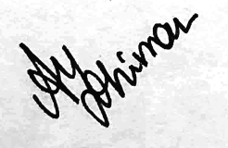



Eshan Madnani Ayush Dhiman

19BCE1470 19BCE1463

 

Suriya Kumar Prithika Shakthi

19BCE1820 19BCE1244

i

**CERTIFICATE**

Certified that this project report entitled “**Detection of Pneumonia by Analysing Chest X-Rays”** is a bonafide work of **Ayush Dhiman (19BCE1463), Eshan Madnani(19BCE1470) , Prithika Shakthi (19BCE1820), Harsh Vardhan(19BCE1661), Muvva Durga Samhitha(19BCE1468), Suriya Kumar(19BCE1244)** and they carried out the Project work under my supervision and guidance for CSE1901 - Technical Answers to Real World Problems (TARP).

**Dr. Nithya Darshini**

SCOPE, VIT Chennai

ii

**ACKNOWLEDGEMENT**

We would like to express my special thanks to my teacher Dr. Nithya Darshini as well as our chancellor Dr. Viswanathan who gave me the golden opportunity to do this wonderful project on the topic **Detection of Pneumonia by Analyzing Chest X-Rays**, which also helped us do a lot of Research and we came to know about so many new things that we are really thankful to learn them.

Secondly we would also like to thank our parents and friends who helped us a lot in finalizing this project within the limited time frame.

iii

**ABSTRACT**

Pneumonia is an infection which afflicts the pulmonary system of the body it manifests in. It causes the air sacs (alveoli) of the lungs to fill with fluid or pus, which in turn causes cough with phlegm or pus, fever, chills and labored breathing. A variety of organisms, including bacteria, viruses and fungi, can cause pneumonia. Bacteria such as Streptococcus pneumonia and Mycoplasma pneumonia are known to cause mild cases of pneumonia. COVID-19, the disease the novel coronavirus causes, can spread to the lungs, causing pneumonia. While many people recover, some develop severe pneumonia that does not respond well to treatment. Doctors can differentiate between a normal and a pneumonia afflicted patient by analyzing their chest X-rays. Doctors can also distinguish between viral and bacterial pneumonia by examining the chest X-ray of the patient. And If the disease is identified in a more user friendly way. The treatment can be taken care of by medical industries.

iv

**CONTENTS**

Declaration i

Certificate ii

Acknowledgement iii

Abstract iv

1 Introduction

1.1 Objective and goal of the project . . . . . . . . . . . . . . .. . . …….1

1.2 Problem Statement. …. . . . . . . . . . . . . . . . . . . . . . . .. . . . . . . 2

1.3 Motivation . . . . . . . . . . . . . . . . . . . . . . . . . . . . ...…………...3

1.4 Challenges…………………………………………………...4

2 Literature Survey………………………………………………………....5

3 Requirements Specification 13

3.1 Software Requirements ……………………………………13

3.2 Technical Requirements…………………………………...13

3.3 Library Requirements……………………………………. .13

4 System Design……………………………………………………...14

5 Implementation of System …………………………………………15

5.1 Doctors Methodology…………………………………………16

5.2 Algorithm Used………………………………………………..17

5.3 Backend Server………………………………………………..20

6 Results & Discussion……………………………………………….23

7 Conclusion and Future Work……………………………………….24

8 References…………………………………………………………..25

Appendix……………………………………………………………26

**1. Introduction**

1.1 **Objective and goal of the project**

The projects objective is to design a Convolution Neural Network and train it by using Machine Learning algorithms to detect and differentiate between normal and Pneumonia afflicted patients by analyzing their Chest X-Rays. Additionally a well defined UI will be designed on the front end to create a user friendly interface, where all the popups, messages and information about the user are informed. The system will also be aimed at providing security in data.

**1.2**  **Problem Statement**

Pneumonia detection using chest X-rays has been an open problem for way too long. Many machine learning models have been extensively studied by the researchers and a lot of advancements have been brought from the day the research started. One of the papers segmented the lung regions from chest X-ray images and extracted eight statistical characteristics. The paper also implemented 5 ML classifiers: multi-layer perceptron (MLP), random forest, sequential minimal optimization (SMO), classification via regression, and logistic regression. But the problem with the Machine Learning algorithms is, the process involves handcrafted features that need to be extracted and selected for classification or segmentation. Additionally most of the solutions found so far have used almost every Machine Learning model combination possible. The project wanted to take an alternative approach rather than Machine learning models. Also, none of the existing projects so far have a proper UI interface and the data security since it involves the data of an individual.

**1.3 Motivation**

Pneumonia affects a large number of individuals, especially children, mostly in developing and underdeveloped countries characterized by risk factors coupled with the unavailability of appropriate medical facilities. Early diagnosis of pneumonia is crucial to cure the disease completely. Examination of X-ray scans is the most common means of diagnosis, but it depends on the interpretative ability of the radiologist. Thus, an automatic CAD system with generalizing capability is required to diagnose the disease.

**1.4 Challenges**

There were quite a few challenges when the work for this project started. The whole project was split into three divisions within ourselves. Front End, Back end and Machine Learning Model. Every phase of the project working had its own problems of their own. Since the data deals with information of patients' health conditions it has to be properly secured. For which we have to make the website trustworthy to the user. Secondly, the ML model. The project used an existing dataset from Kaggle, on which preprocessing is performed. The process where we created two arrays one with the images and other with the labels respective to images(o if no pneumonia & 1 if has pneumonia). The major problem was covering the model. When we started fitting the model, since the dataset is of 2.5 GB and the platform used was Google collab. It frequently kept on crashing before implementing the model. Because of which only 10 epochs could be implemented however we further tried to implement and covnerge the algorithm. Even the backend was secured properly.

**2. Literature Survey**

Early detection of pneumonia is crucial for determining the appropriate treatment of the disease and preventing it from threatening the patient’s life. Chest radiographs are the most widely used tool for diagnosing pneumonia; however, they are subject to inter-class variability and the diagnosis depends on the clinicians’ expertise in detecting early pneumonia traces. To assist medical practitioners, an automated CAD system was developed in this study, which uses deep transfer learning-based classification to classify chest X-ray images into two classes “Pneumonia” and “Normal.” An ensemble framework was developed that considers the decision scores obtained from three CNN models, GoogLeNet, ResNet-18, and DenseNet-121, to form a weighted average ensemble. Some instances the ensemble framework failed to produce correct predictions. In the future, they will investigate techniques such as contrast enhancement of the images or other preprocessing steps to improve the image quality. [1]

This paper by [Kartik Thakral](https://ieeexplore.ieee.org/author/37087052411), [Lucky Agarwal](https://ieeexplore.ieee.org/author/38232400100) et al primarily aims to improve medical adeptness in areas where the availability of radiotherapists is still limited. There were some limitations ,the first biggest limitation was that there was no history of the associated patient considered in the evaluation model. Secondly, only frontal chest X-rays were used but it has been shown that lateral view chest X-rays are also helpful in diagnosis. Thirdly, since the model exercises a lot of convolutional layers, the model needs very high computational power otherwise it’ll eat up a lot of time in computations. [2]

In this paper, Tatiana Gabruseva, Dmytro Poplavskiy et al have proposed a simple and effective algorithm for the localization of lung opacities regions. The model was based on single-shot detector RetinaNet with Se-ResNext101 encoders, pre-trained on ImageNet dataset.The number of improvements was implemented to increase the accuracy of the model. In particular, the global classification output was added to the model, heavy augmentations were applied to the data, the ensemble of 4 folds and several checkpoints was unitised to generalize the model. Ablation studies have shown the improvements by the proposed approaches for the model accuracy. This method purposely does not involve test-time augmentation and provides a good trade-off between accuracy and resources. The reported method achieved one of the best results in the challenge. [3]

In this work, Amit Kumar Jaiswal , Prayag Tiwari et al have presented their approach for identifying pneumonia and understanding how the lung image size plays an important role for the model performance. They found that the distinction is quite subtle for images among the presence or absence of pneumonia, a large image can be more beneficial for deeper information. However, the computation cost also burdens exponentially when dealing with large images. Our proposed architecture with regional context, such as Mask-RCNN, supplied extra context for generating accurate results. Also, using thresholds in background while training tuned their network to perform well in this task.With the usage of image augmentation, dropout and L2 regularization prevented the overfitting, but obtained somewhat weaker results on the training set with respect to the test. Their model can be improved by adding new layers, but this would introduce even more hyperparameters that should be adjusted. [4]

Bandar Almaslukh et al proposed an automatic detection system using the pre-trained DenseNet-121for feature extraction and Deep Neural Network based classification, which achieved an accuracy of 98.90% on the testing set. The results also say that the processing time is very minimal making the model lightweight and quick. [5]

In this journal by [Ayan](https://ieeexplore.ieee.org/author/37086399479), [Halil Murat Ünver](https://ieeexplore.ieee.org/author/37086233972) et al, a new algorithm, Deep convolutional neural network has been introduced, that counterfeits the challenges of its predecessors. It has been found that this model can be used for any medical imaging application with a large unlabelled dataset and a small labeled dataset to improve the accuracy of the results. [6]

To train the model, they have used transfer learning and fine tuning. Xception model uses a modified depth wise separable convolutional layer that has 36 convolutional layers for feature extraction followed by a logistic regression layer. The other deep model is named VGG-16 that has 16 convolutional layers with small receptive fields, five max pooling layers and three fully-connected layers having a soft-max activation function.The test results showed that Vgg16 network exceeds Xception network based on accuracy. However, the Xception network achieved a more successful result in detecting pneumonia cases. As a result, we realized that every network has its own special capabilities on the same dataset. [7]

Chest X-ray (CXR) is one of the most used imaging techniques for detection and diagnosis of pulmonary diseases.A CXR provides a large amount of information about a patient. In this research paper, they have presented an automatic lung segmentation method that addresses the major challenge of lung segmentation in CXR which is to include in the segmentation mask the regions of the lung field overlapped by abnormal structures by performing a reconstruction step on the affected lung regions. For this purpose, several techniques are used, which include two convolutional neural networks (AlexNet, to perform patch classification & ResNet18, to perform a reconstruction of missing parts of the lung field) and other image processing techniques such as morphological operations and filtering. [8]

A CXR scoring system (named Brixia score) is designed exclusively for semi-quantitative assessment of lung disease in COVID-19, ranking the pulmonary involvement on an 18-point severity scale according to extent and characteristics of lung abnormalities. [9]

Dejun Zhang et al have described a CNN-based model aiming to diagnose pneumonia on a chest X-ray image set. They utilized the Dynamic Histogram Equalization (DHE) technique to enhance the image contrast. Then, they designed a simple CNN model to extract the features and obtain results. This model can be improved to classify the two types of pneumonia i.e virus and bacteria. [10]

[Dong Jin Park](https://www.nature.com/articles/s41598-021-87171-5#auth-Dong_Jin-Park) et al could predict 39 diseases accurately that are relatively commonly observed in patients visiting the emergency room. Various models are mixed and combined and the results are tabulated. Then the models are compared using various methods where they incorporate the data visualization. Correlation matrix, K-fold cross-validation, SHAP (Shapley Adaptive Explanations) etc. Performance measures that this project opted for are F1 score, accuracy and ROC curve. The paper however has a proper evaluation measure but could only predict 39 diseases overall. The models should be trained in such a way that they pick a particular domain and work on all the diseases related to that else it should have concentrated on one particular disease and evaluated the countermeasures. [11]

[Shahadat Uddin](https://bmcmedinformdecismak.biomedcentral.com/articles/10.1186/s12911-019-1004-8#auth-Shahadat-Uddin) et al, provided a wide overview of the relative performance of different variants of supervised machine learning algorithms for disease prediction which can be used by researchers further. The paper concludes that the Support Vector Machine (SVM) algorithm is applied most frequently followed by the Naïve Bayes algorithm . However, the Random Forest algorithm showed superior accuracy comparatively.This was followed by SVM in accuracy. Additionally Classifier performance index has been performed for each of the models evaluated to understand the accuracy. The paper provides extensive and detailed results where the results are well defined and tabulated comparing the 2 of the models that are considered in the whole research. It is a well defined and structured work for any ML based projects not just medical field. However the same supervised learning algorithms when considered differently can generate different results across various study settings. There is a chance that a performance comparison between two supervised learning algorithms can generate imprecise results if they were employed in different studies separately. On the other side, the results of this study could suffer a variable selection bias from individual articles considered in this study. [12]

**3.** **Requirements Specification**

3.1 **Software Requirements**

* MongoDB Compass
* VS Code
* Google Collab
* Jupyter Notebook

3.2 **Technological Requirements**

* Flask
* Python 3.9
* MongoDB
* HTML
* CSS
* JavaScript

3.3 **Library Requirements**

* Tensorflow
* Pandas
* Numpy
* Matplotlib
* hashlib
* cv2
* flask_pymongo

**4 System Design**

CNN-based deep learning algorithms have become the go-to resource for medical image analysts. Medical image classification plays an essential role in clinical treatment and teaching tasks. The deep neural network is an emerging machine learning method that has proven its potential for different classification tasks. Convolutional Neural Network dominates with the best results on varying image classification tasks. We have applied the convolutional neural network (CNN) based algorithm on a chest X-ray dataset to classify pneumonia. The algorithm used to train the Neural Network is called Transfer Learning algorithm. Transfer Learning is a simple and popular approach in deep learning where a model developed for a task is reused as the starting point for a model on a second task. We have also intended to prime our input dataset by de-noising it with the help of filters. Different numbers of epochs and filters have been used in the CNN to ensure the highest possible output accuracy. The output displayed via a Confusion Matrix is to showcase the accuracy and precision of the model designed.

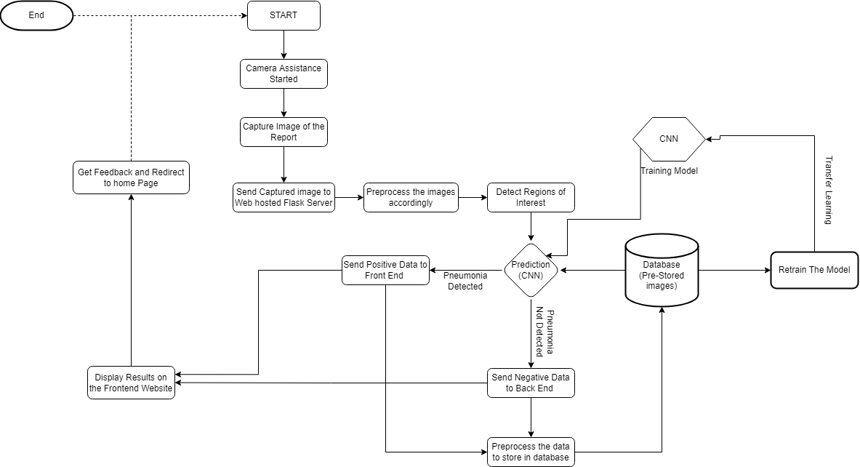

**5 Implementation of System**

**5.1 DOCTORS METHODOLOGY:**

The project’s primary doctor will begin by asking the user about their medical history and symptoms. User will also undergo a physical exam, so that your doctor can listen to your lungs. In checking for pneumonia, the doctor will listen for abnormal sounds like crackling, rumbling or wheezing. If the doctor thinks user might have pneumonia, an imaging test may be performed to confirm the diagnosis. One or more of the following tests may be ordered to evaluate for pneumonia: Chest x-ray: An x-ray exam will allow the doctor to see user’s lungs, heart and blood vessels to help determine if user has pneumonia. When interpreting the x-ray, the radiologist will look for white spots in the lungs (called infiltrates) that identify an infection. This exam will also help determine if user has any complications related to pneumonia such as abscesses or pleural effusions (fluid surrounding the lungs).

**5.2 ALGORITHM USED :**

**5.2.1 Dataset Preprocessing:**

A function to label the images in the dataset based upon whether the person is normal or diagnosed with pneumonia. Normal patients have been labeled 0 Pneumonia diagnosed patients have been labeled 1. This function takes the dataset directory as an argument written to perform pre-processing on the image dataset which includes Image gray-scaling, Image resizing, Storing the grayscale values and labels in x and y variables. The function is essentially used to assign labels to the images depending on whether they are normal x rays or pneumonia x-rays, resize the image and store the images in the array X and the labels in the array y

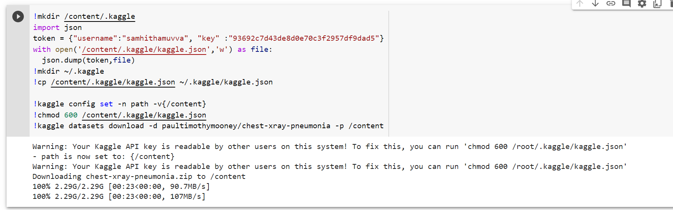

**5.2.2 Training and Testing data:**

The wohle code is designed in such a way that it prints the shape of X_train and X_test. The output (5216, 150, 150, 3) means that X_train has 5216 images which are 150x150 pixels and they are colored images (not grayscale). X_test has 624 images which are 150x150 pixels and they are colored images (not grayscale). Similarly its also prints the shape of y_train and y_test. They have two columns; one column is pneumonia or normal and the other column has values of 1 or 0

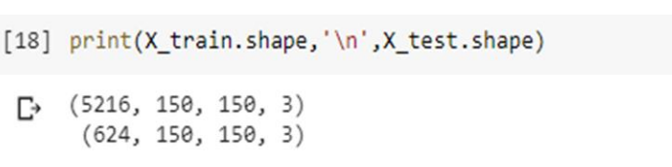

**4.2.3 Pneumonia images function:**

Define a function to plot images of x-rays that are normal and those that are of pneumonia. Using matplotlib to demonstrate pneumonia and no pneumonia images side by side. Models often benefit from reducing the learning rate once learning stagnates. For this, we used ReduceLROnPlateau which monitors accuracy setting the factor by which to reduce learning rate as 0.1. Verbose is 1: update messages.

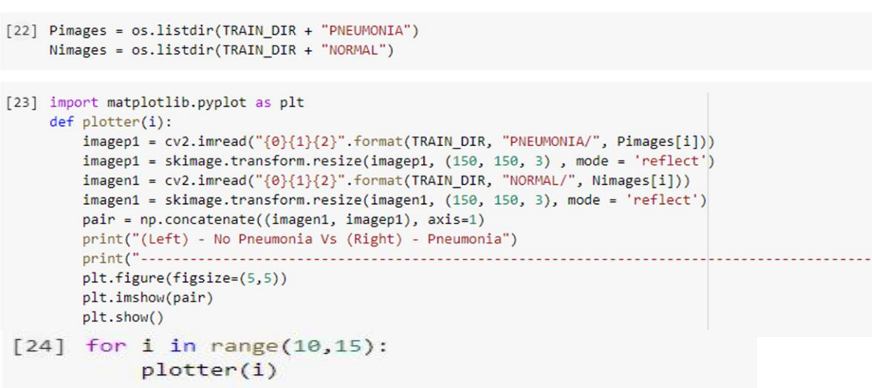

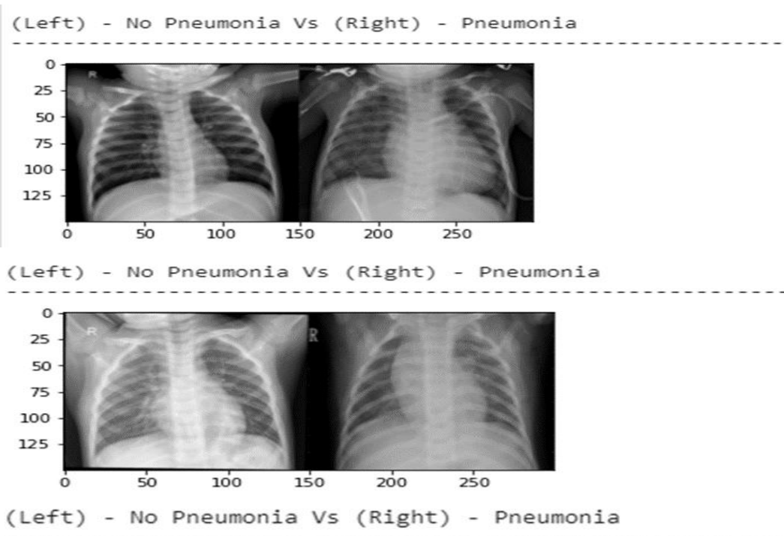

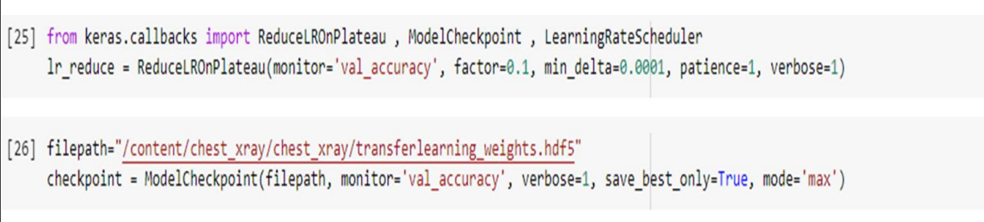

**5.2.4 Transfer Learning Algorithm:**

Transfer learning is a machine learning method where a model developed for a task is reused as the starting point for a model on a second task. It is a popular approach in deep learning where pre-trained models are used as the starting point on computer vision and natural language processing tasks given the vast compute and time resources required to develop neural network models on these problems and from the huge jumps in skill that they provide on related problems. We aim to apply the convolutional neural network (CNN) based algorithm on a chest X-ray dataset to classify pneumonia. The algorithm used to train the Neural Network is called the Transfer Learning algorithm. Transfer Learning is a simple and popular approach in deep learning where a model developed for a task is reused as the starting point for a model on a second task. We also intend to prime our input dataset by de-noising it with the help of filters. Different number of epochs and filters will be used in the CNN to ensure the highest possible output accuracy. The output will be displayed via a Confusion Matrix to showcase the accuracy and precision of the model designed.

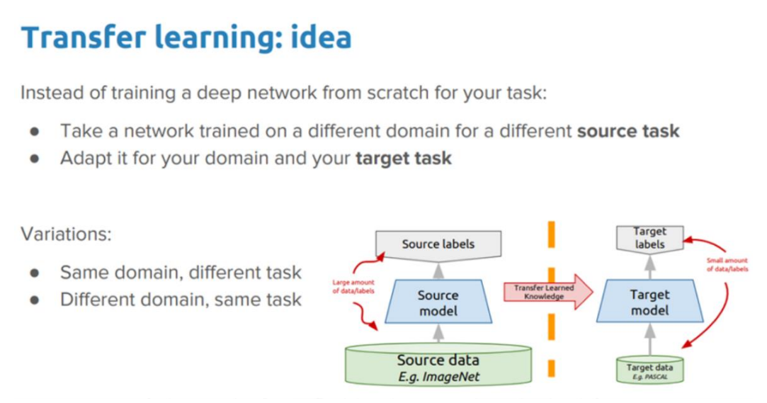

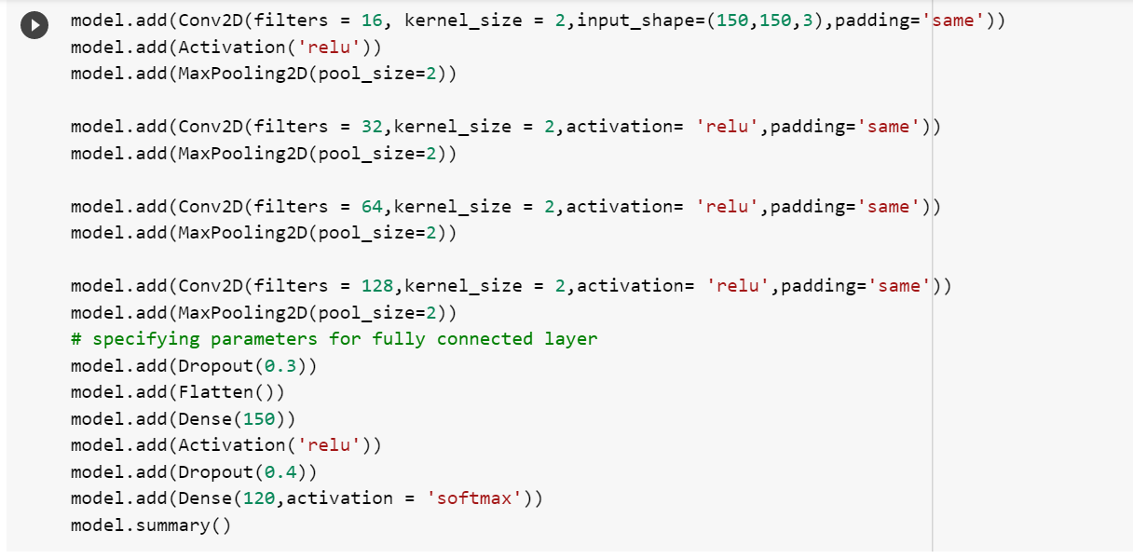

**5.3 BACKEND SERVER:**

**5.3.1 Creating server for front-end**

Using Flask Technology, a set up is made with local virtual environment which is used to develop and deploy a flask server to host the front-end web application on which backend was also integrated with the machine learning model.

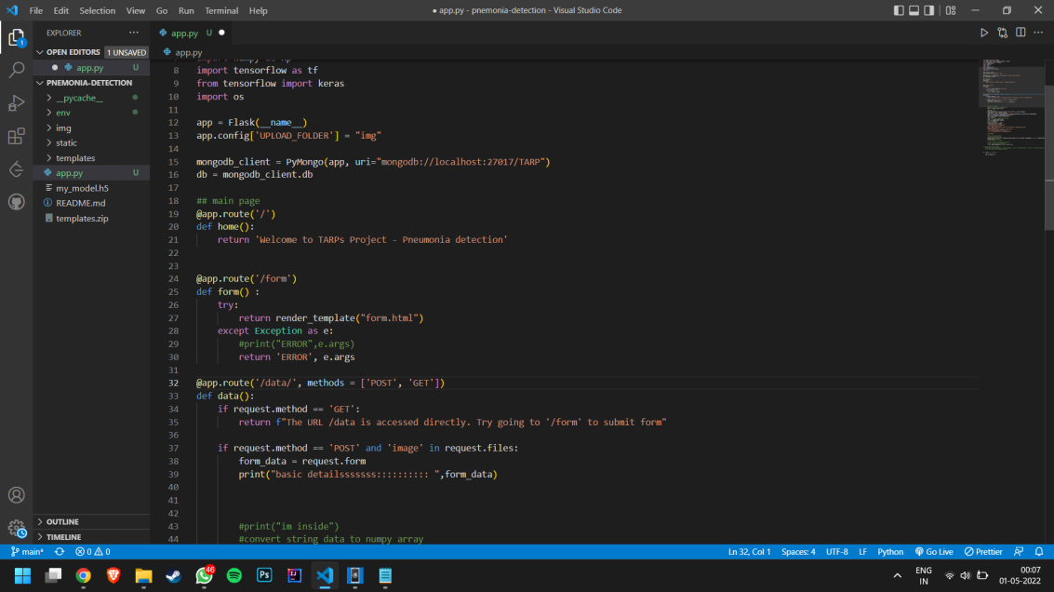

**5.3.2 Encrypting and storing data**

After the user inputs their data onto the front end, the sensitive information received on the flask backend like their name, email, location, etc are encrypted using MD5 encryption before storing them onto the MongoDB database.

The sensitive encrypted data along with their pneumonia detection result from the “.h5” ML model is stored in the NoSql MongoDB database.



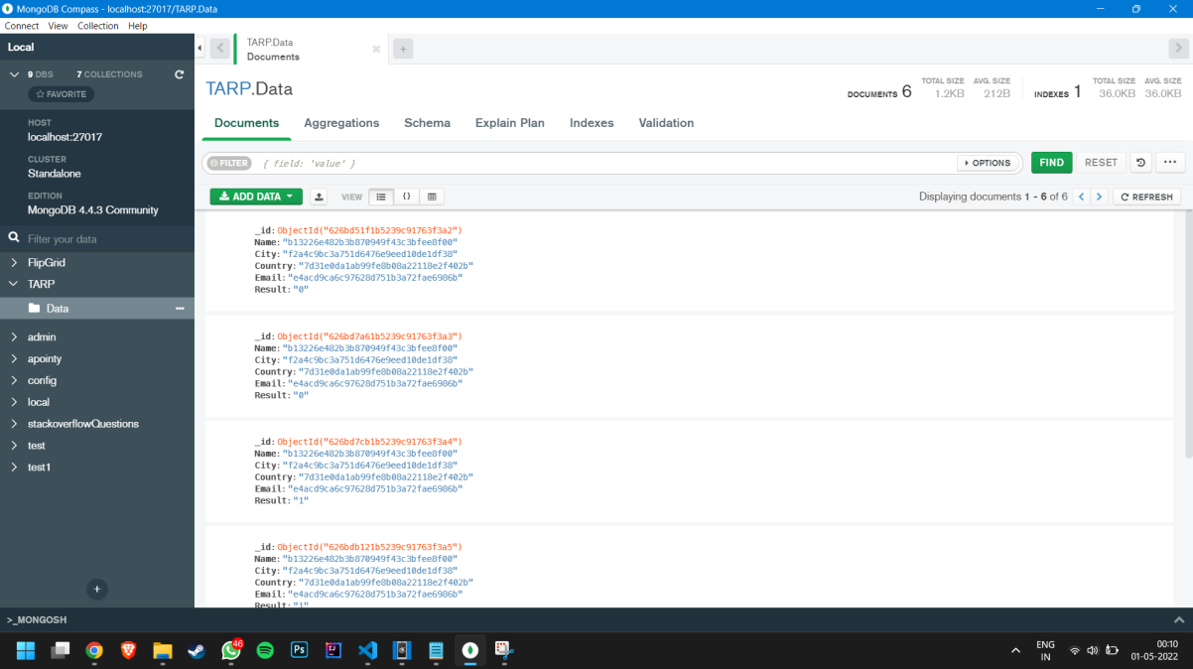

**5.3.3 Integrating Machine Learning Model**

After training the ML model on google collab, the ML model was downloaded as a “.h5” file to integrate into the flask server which was then used for predicting the presence of pneumonia when an user uploads the X-Ray scan on the website. Once the image is uploaded by the user, the image is preprocessed by converting it into grayscale, resizing and reshaping which helps in better prediction.

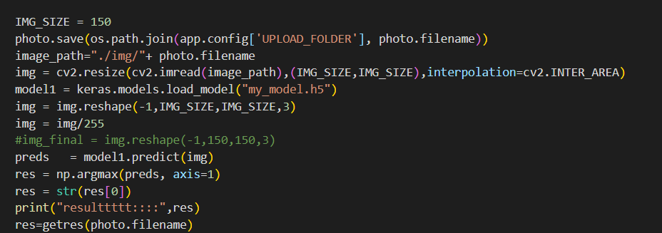

**6. Results and Discussion**

Detection of Pneumonia by Analyzing Chest X-Rays is a small step towards revolutionizing the application of image processing using Machine Learning and Neural Networks in the field of medicine. Our model was able to deliver an accuracy of 97% for detecting pneumonia. Transfer Learning Algorithm was the core of this project which helped in getting highly accurate data at great speeds. Our goal in mind while coming up with an idea for this project was to ease the burden shouldered by millions of doctors across the world who are working ceaselessly to treat people from the devastating effect of COVID-19 caused by the novel coronavirus. Since a COVID-19 afflicted patient displays symptoms of pneumonia, a disease which can also be contracted through bacterial means, it becomes increasingly difficult to differentiate between the two types of patients based on a human's perspective on their chest X-rays and to treat the patients with the proper care that they need. There have been several instances of mislabelling patients with similar pneumonia-like symptoms due to the sheer volume of COVID-19 afflicted patients and this hampers the treatment. Our project could be a first step towards making the process of identification and differentiation of pneumonia through a machine’s analysis of chest X-rays. By off-loading some of their work onto machines, doctors can spend more time attending to more pressing matters and can also safely and reliably treat their patients.

**7. Conclusion and Future Work**

Early detection of pneumonia is crucial for determining the appropriate treatment of the disease and preventing it from threatening the patient’s life. Chest radiographs are widely used tools for diagnosing pneumonia; but, they are subject to inter-class variability and the diagnosis depends on the doctor’s expertise in detecting early pneumonia traces. To ease this, we developed a system, which uses deep transfer learning-based classification to classify chest X-ray images into two classes “Pneumonia” and “Normal.” An ensemble framework was developed that considers the decision scores obtained from CNN models - Transfer Learning approach, to form a weighted average ensemble. The weights assigned to the classifiers were calculated using a novel strategy wherein four evaluation metrics, precision, recall, f1-score, and AUC, were fused using the hyperbolic tangent function. The framework, evaluated on the publicly available pneumonia chest X-ray datasets, obtained an accuracy rate of 97%. Furthermore, the proposed ensemble model is domain-independent and thus can be applied to a large variety of computer vision tasks.

However, in some instances the ensemble framework failed to produce correct predictions. In the future, we may make use of other image processing techniques such as contrast enhancement of the images or other preprocessing steps to improve the image quality. We could also think about segmenting the lung image before classifying it to help the CNN models get better feature extraction. Furthermore, because three CNN models are required to train the proposed model, the computation cost is higher than that of the CNN. The study will likely lead to the development of better algorithms for detecting Pneumonia in the foreseeable future.

**8**. **REFERENCES**

# Kundu R, Das R, Geem ZW, Han GT, Sarkar R. Pneumonia detection in chest X-ray images using an ensemble of deep learning models. PLoS One. 2021 Sep 7;16(9):e0256630. doi: 10.1371/journal.pone.0256630. PMID: 34492046; PMCID: PMC8423280.

# Pneumonia Detection Using CNN based Feature Extraction, [Dimpy Varshni](https://ieeexplore.ieee.org/author/37087051805); [Kartik Thakral](https://ieeexplore.ieee.org/author/37087052411); [Lucky Agarwal](https://ieeexplore.ieee.org/author/38232400100); [Rahul Nijhawan](https://ieeexplore.ieee.org/author/37086317951); [Ankush Mittal](https://ieeexplore.ieee.org/author/37270139200)

# Deep Learning for Automatic Pneumonia Detection Tatiana Gabruseva, Dmytro Poplavskiy Topcon Positioning Systems Brisbane, Queensland, Australia

# Identifying pneumonia in chest X-rays: A deep learning approach Amit Kumar Jaiswal a , Prayag Tiwari b , Sachin Kumar c , Deepak Gupta d , Ashish Khanna d , Joel J.P.C. Rodrigues

# Almaslukh2021ALD,A Lightweight Deep Learning-Based Pneumonia Detection Approach for Energy-Efficient Medical Systems, author={Bandar Almaslukh},journal={Wirel.Commun.Mob. Comput.}, year={2021}, volume={2021}, pages={5556635:1-5556635:14}

# }Novel Transfer Learning Approach for Medical Imaging with Limited Labeled Data [Laith Alzubaidi](https://www.ncbi.nlm.nih.gov/pubmed/?term=Alzubaidi%20L%5BAuthor%5D&cauthor=true&cauthor_uid=33808207), [Muthana Al-Amidie](https://www.ncbi.nlm.nih.gov/pubmed/?term=Al-Amidie%20M%5BAuthor%5D&cauthor=true&cauthor_uid=33808207), [Ahmed Al-Asadi](https://www.ncbi.nlm.nih.gov/pubmed/?term=Al-Asadi%20A%5BAuthor%5D&cauthor=true&cauthor_uid=33808207), [Amjad J. Humaidi](https://www.ncbi.nlm.nih.gov/pubmed/?term=Humaidi%20AJ%5BAuthor%5D&cauthor=true&cauthor_uid=33808207), [Omran Al-Shamma](https://www.ncbi.nlm.nih.gov/pubmed/?term=Al-Shamma%20O%5BAuthor%5D&cauthor=true&cauthor_uid=33808207), [Mohammed A. Fadhel](https://www.ncbi.nlm.nih.gov/pubmed/?term=Fadhel%20MA%5BAuthor%5D&cauthor=true&cauthor_uid=33808207), [Jinglan Zhang](https://www.ncbi.nlm.nih.gov/pubmed/?term=Zhang%20J%5BAuthor%5D&cauthor=true&cauthor_uid=33808207),1 [J. Santamaría](https://www.ncbi.nlm.nih.gov/pubmed/?term=Santamar%26%23x000ed%3Ba%20J%5BAuthor%5D&cauthor=true&cauthor_uid=33808207), and [Ye Duan](https://www.ncbi.nlm.nih.gov/pubmed/?term=Duan%20Y%5BAuthor%5D&cauthor=true&cauthor_uid=33808207)

# Ayan, E., Karabulut, B. & Ünver, H.M. Diagnosis of Pediatric Pneumonia with Ensemble of Deep Convolutional Neural Networks in Chest X-Ray Images. *Arab J Sci Eng* 47, 2123–2139 (2022). <https://doi.org/10.1007/s13369-021-06127-z>

# An automatic method for lung segmentation and reconstruction in chest X-ray using deep neural networks [Johnatan Carvalho Souza](https://pubmed.ncbi.nlm.nih.gov/?term=Souza+JC&cauthor_id=31319957) , [João Otávio Bandeira Diniz](https://pubmed.ncbi.nlm.nih.gov/?term=Bandeira+Diniz+JO&cauthor_id=31319957) , [Jonnison Lima Ferreira](https://pubmed.ncbi.nlm.nih.gov/?term=Ferreira+JL&cauthor_id=31319957) , [Giovanni Lucca França da Silva](https://pubmed.ncbi.nlm.nih.gov/?term=Fran%C3%A7a+da+Silva+GL&cauthor_id=31319957) , [Aristófanes Corrêa Silva](https://pubmed.ncbi.nlm.nih.gov/?term=Corr%C3%AAa+Silva+A&cauthor_id=31319957) , [Anselmo Cardoso de Paiva](https://pubmed.ncbi.nlm.nih.gov/?term=de+Paiva+AC&cauthor_id=31319957).

# Signoroni A, Savardi M, Benini S, Adami N, Leonardi R, Gibellini P, Vaccher F, Ravanelli M, Borghesi A, Maroldi R, Farina D. BS-Net: Learning COVID-19 pneumonia severity on a large chest X-ray dataset. Med Image Anal. 2021 Jul;71:102046. doi: 10.1016/j.media.2021.102046.

# Zhang, Dejun, Fuquan Ren, Yushuang Li, Lei Na, and Yue Ma. 2021. "Pneumonia Detection from Chest X-ray Images Based on Convolutional Neural Network" Electronics 10, no. 13: 1512. <https://doi.org/10.3390/electronics10131512>

# Development of machine learning model for diagnostic disease prediction based on laboratory tests [Dong Jin Park](https://www.nature.com/articles/s41598-021-87171-5#auth-Dong_Jin-Park) Uddin, S., Khan, A., Hossain, M. *et al.* Comparing different supervised machine learning algorithms for disease prediction. *BMC Med Inform Decis Mak* 19, 281 (2019). <https://doi.org/10.1186/s12911-019-1004-8>

# APPENDIX

**Frontend**

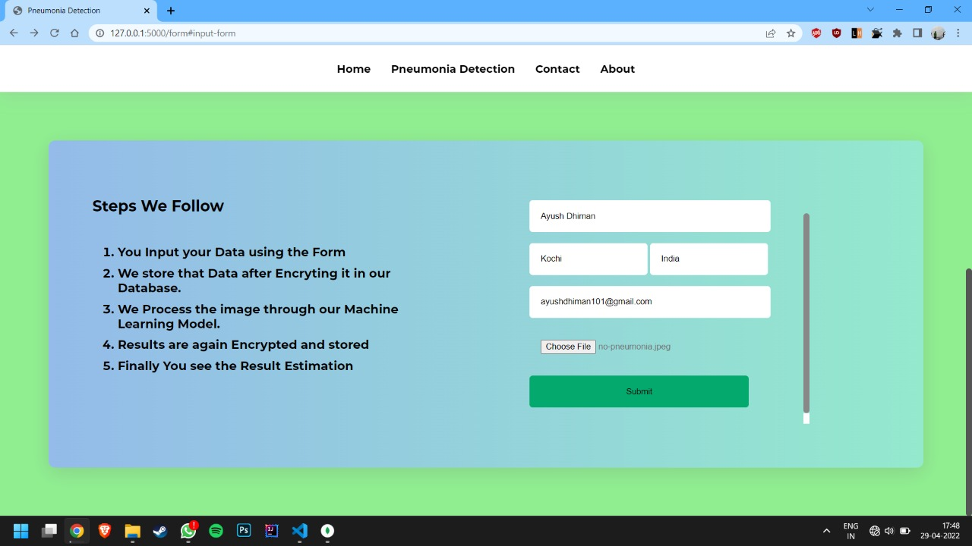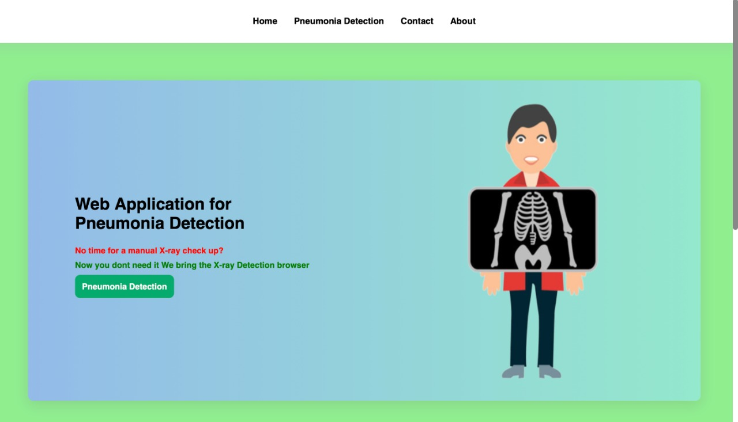

**Output :**

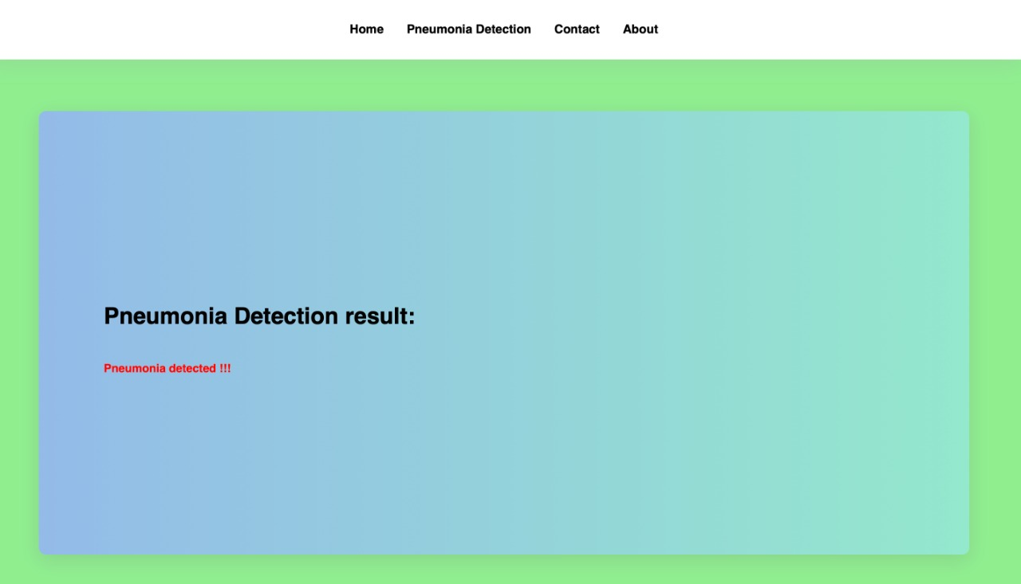

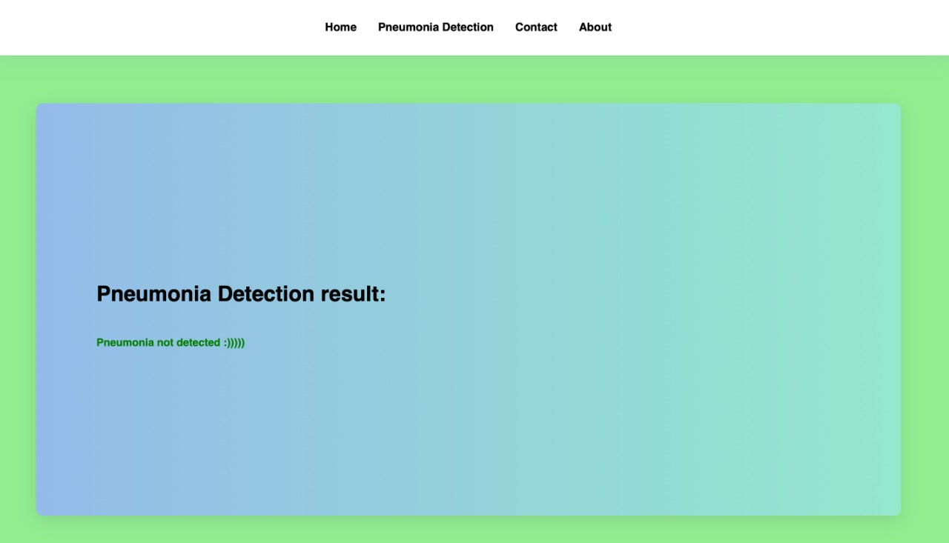

**Backend :**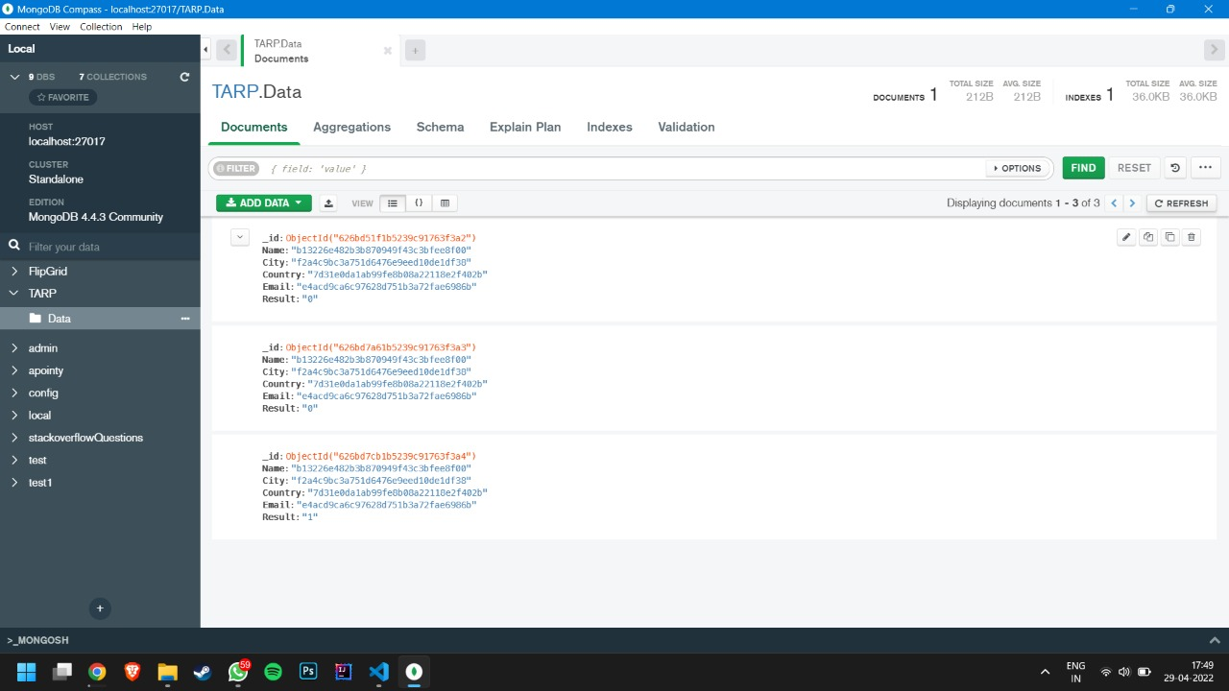

**ML Model:**

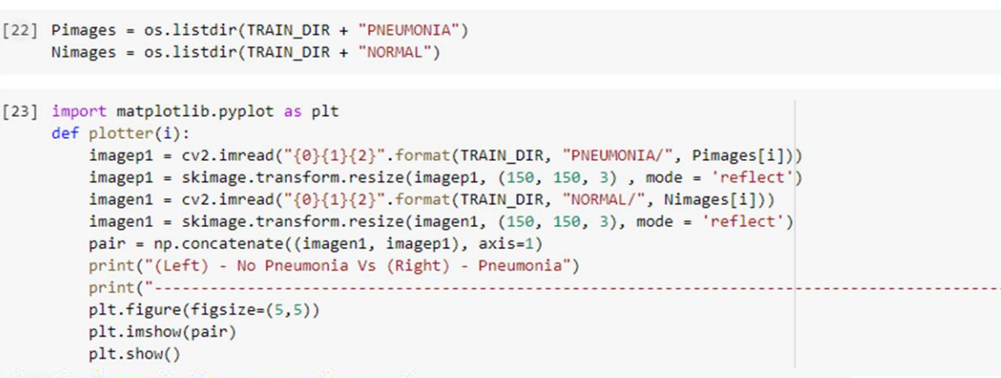

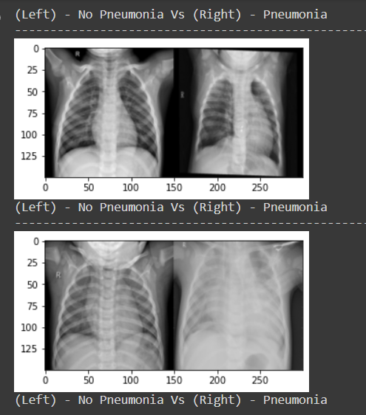

fig 9.1: chest x-ray dataset

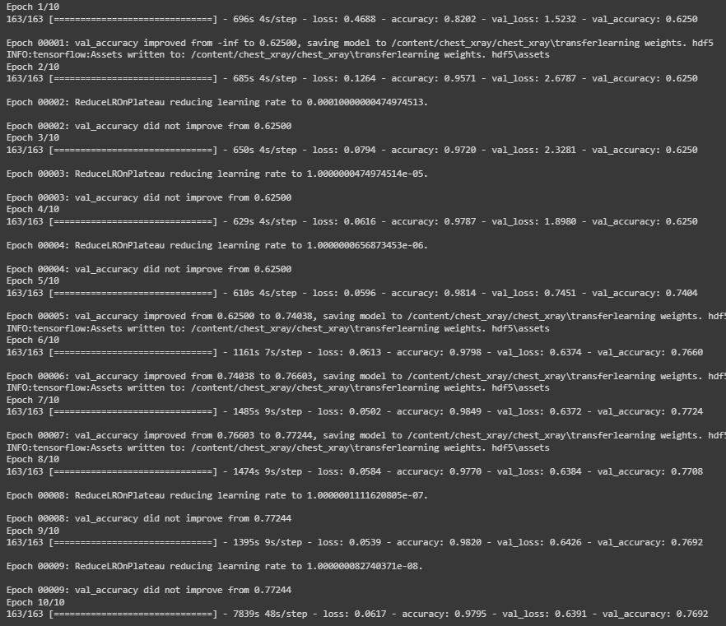

fig 9.2: fitting the model

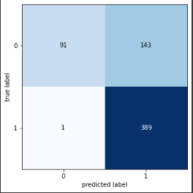

fig: confusion matrix

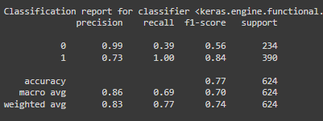

fig performance metrics

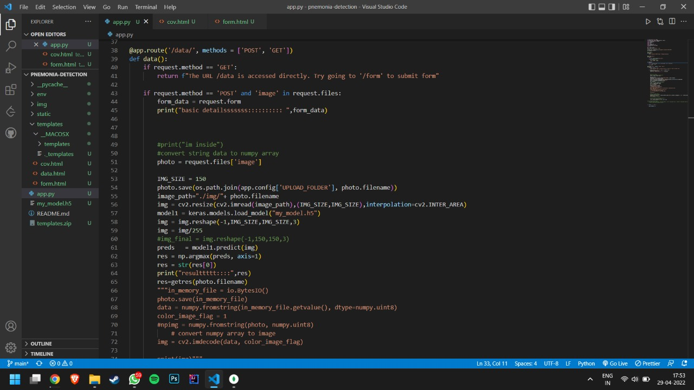**Backend server code snippets :**

